**Easy Worship Custom Key Bindings Guide**

1 - **Windows Arrows Key Bindings**

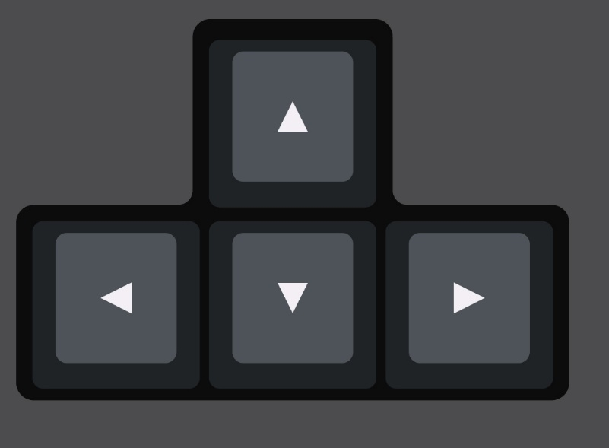

Select the previous schedule file.

Go to the next slide.

Go to the previous slide.

Select the next schedule file.

Control Scroll Bar DOWN

Logo Toggle

Black Screen Toggle

Clean Screen Toggle

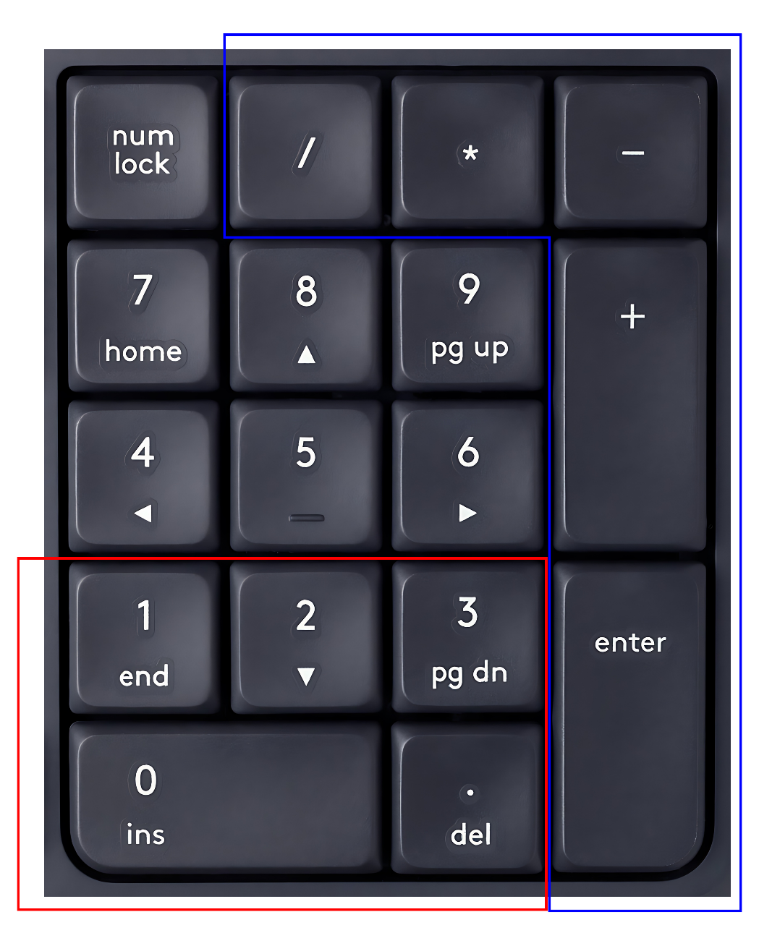

Control Scroll Bar UP

Go to Second Slide

Go to

First Slide

Go Live

Adding to the Schedule

Go Live

Black Screen Toggle

Windows Workspace 1 (PowerPoint)

Windows Workspace 2 (Easy Worship)

Windows Workspace 3

**Summary of used colours**

RED BOX / RED COLOR ARROWS = Main Controls

BLUE BOX / BLUE COLOR ARROWS = Secondary / Backup Controls

Orange Colour Arrows = Go to First Slide or Second Slide

Purple Colour Arrows = Control Scroll Bar

2 - “Windows Desktop Switcher” Script Key Bindings



Go to Windows Virtual Workspace 1

(Main Windows Workspace)

[PowerPoint]

Numpad 1 =



Go to Windows Virtual Workspace 2

[Easy Worship]

Numpad 2 =

Numpad 3 =

Go to Windows Virtual Workspace 3 (Backup Workspace)

* The Windows Desktop Switcher script does not create this workspace.
* If you want to use workspace 3, you must create it manually.
* The Windows Desktop Switcher also manages Control Scroll bar and Go to Second slide.

Create a New Virtual Desktop

You can do this by pressing the "Caps Lock" key and the "C" key at the same time.

(Caps Lock + C)

Delete the Current Virtual Desktop

You can do this by pressing the "Caps Lock" key and the "D" key at the same time.

(Caps Lock + D)